Module 5:
b) Develop a PHP program to manage the state information about the user by using PHP Session.

To store information accessible across web pages, we use sessions. Session is not stored on the user browser like Cookies, hence it is a more secure option.

As we know HTTP is a stateless protocol, if a user visits a webpage and perform some action, there is no way to remember what he did when the user navigates to the next webpage.
Let's take a practical example, when you log into your facebook account, by providing your email address and password, until and unless you logout, the web application remembers who you are and display what your friends are posting and liking on your News Feed, you can update your profile, send someone message, join a group etc, this is accomplished by Session.
When a user logs into their account on any web application, a session is created for them, and in the session their username or userid or some other unique identifier is stored, which is then used on the consecutive webpages to show information specific to that user. On logout, the session is destroyed.
Session is not limited by any size limit, you can store any information in the session, irrespective of its size.

Real world Use of Session
- Web applications which require a user to login, use session to store user information, so that on every webpage related information can be displayed to the user.
- In eCommerce websotes, shopping cart is geberally saved as part of session.

Start a Session in PHP
In PHP we can start a session by using the session_start() function. And data is stored in the session using session variable, which can be assigned different values using global variable $_SESSION
In simpler words, using the function session_start() we initialize the session, in which we can store information using the session variable $_SESSION.
Let's take an example; below we have a webpage with Php file named
start_session_page.php
<?php
session_start(); // start the session

$_SESSION["username"] = "cse"; // set the session variable

$_SESSION["userid"] = "501"; // set the session variable

?>
<html>
<body>
<?php
echo "Session variable is set.";
?>
<center>
<h1>
<a href="second_page.php">Go to Second Page</a>
</h1>
</center>
</body>
</html>

NOTE: The function session_start() should be the first statement of the page, before any HTML tag.

Getting PHP Session Variable Values
In the code above, we have started a session and set two session variables. Above webpage will also have a link to navigate to Second page second_page.php.
Below is the code for second_page.php, in which we fetch values from the session variable which are set in the start_session_page.php.
second_page.php
<?php
session_start(); // start the session
$username = $_SESSION["username"]; // get the session variable values
$userid = $_SESSION["userid"]; // get the session variable values
?>
<html>
<body>
<center>

<h1>
<?php
echo "User Name is: ".$username."<br/>";
echo "User Id is: ".$userid;
?>
</h1>
</center>
</body>
</html>

OUTPUT:

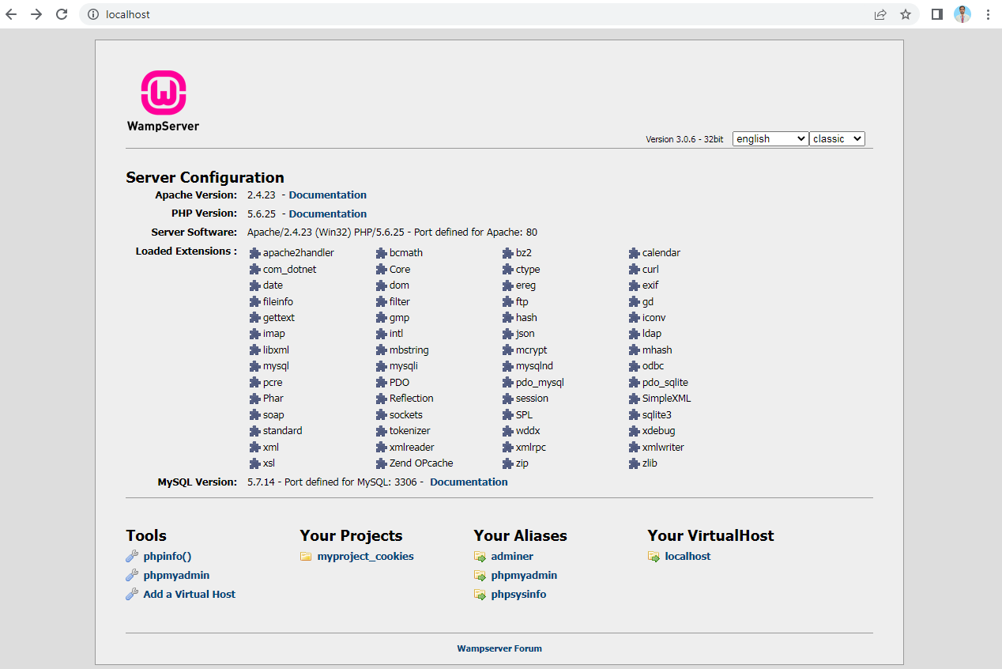
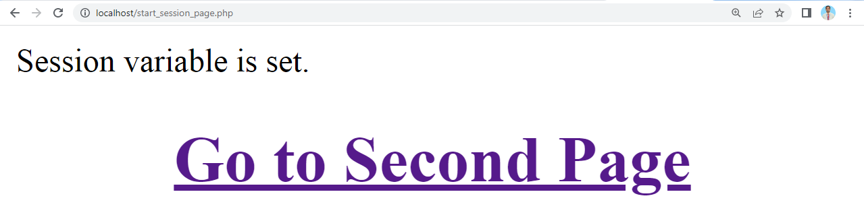

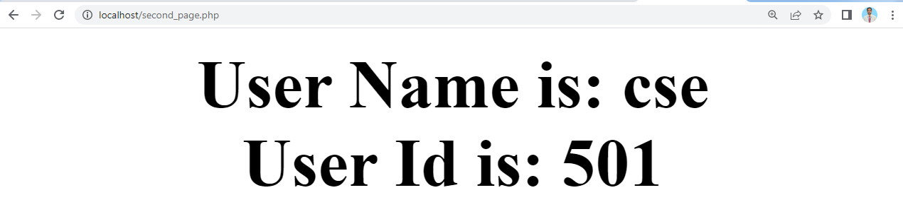
You must be thinking, why we used session_start() in “second_page.php” although we did not set any new values in the session variable.
session_start() function is used to initialize a new session and to fetch the ongoing session(if already started), and then, using the $_SESSION global variable, we can either set new values into the session or get the saved values.
If there are too many values stored in the session, and you don't know which one do you want to get, you can use the below code to print all the current session variable data.
print_all_session.php
<?php
session_start();// start the session
?>
<html>
<body>
<?php
print_r($_SESSION);
?>
</body>
</html>

OUTPUT: 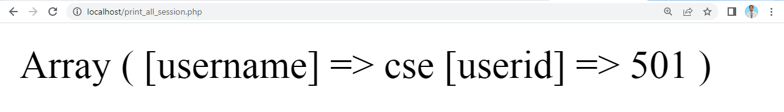

Update Session Variable in PHP
To update any value stored in the session variable, start the session by calling session_start() function and then simply overwrite the value to update session variable.
Update_session.php
<?php
session_start(); // start the session
echo "Before Update User Name & User Id"."<br/>";
echo "User Name is: ".$_SESSION["username"]."<br/>";
echo "User Id is: ".$_SESSION["userid"]."<br/>";
$_SESSION["userid"] = "511"; // update the session variable values
?>
<html>
<body>
<?php
echo "After Update User Name & User Id"."<br/>";
echo "User Name is: ".$_SESSION["username"]."<br/>";
echo "User Id is: ".$_SESSION["userid"];
?>
</body>
</html>

OUTPUT:
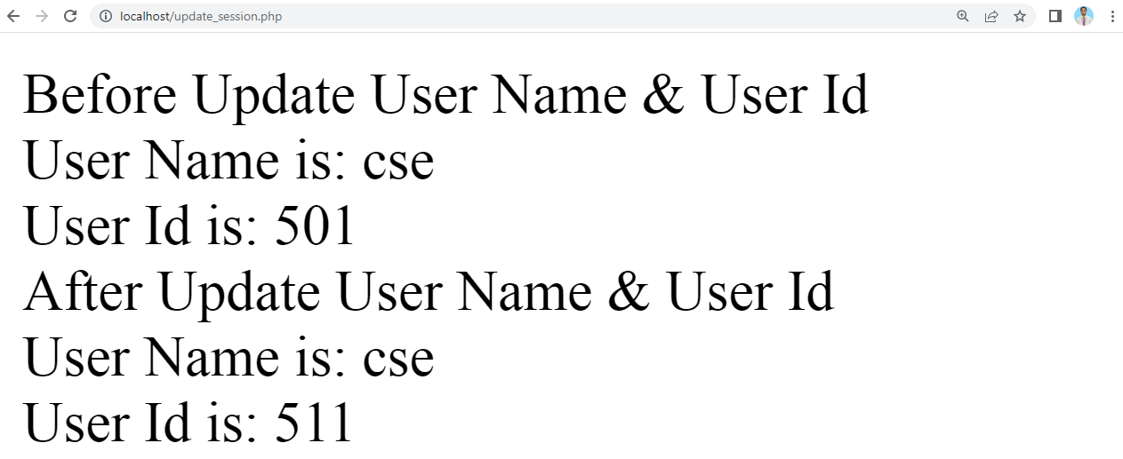

Destroy a Session in PHP
To clean the session variable or to remove all the stored values from the session variable we can use the function session_unset() and to detroy the session, we use session_destroy() function.
session_destroy.php
<?php
session_start(); // start the session
?>
<html>
<body>
<?php
session_unset(); // clean the session variable
session_destroy();// destroy the session
echo "Session Destroy Successfuly";
?>
</body>
</html>

OUTPUT:
